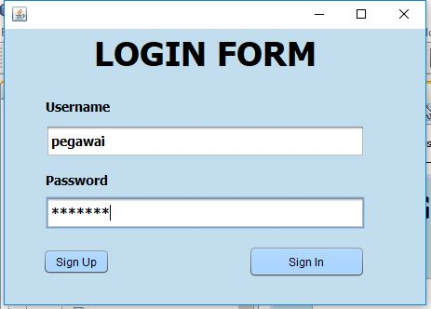

**Sign In Button Script :**

private void signActionPerformed(java.awt.event.ActionEvent evt) {

// TODO add your handling code here:

if(username.getText().equals("admin") && password.getText().equals("admin")){

new menu().setVisible(true);

dispose();

}else if(username.getText().equals("pegawai") && password.getText().equals("pegawai")){

new pelanggan().setVisible(true);

dispose();

}

}